60. Shyam Lal College (Evening), http://www.slce.in Phone : 22324883

Shahadara, Delhi-110032

CENTRAL DELHI
shyamlal_e@yahoo.co.in

Website/Email
Fax No. : 22324078

Telephone/Fax

61. Vivekananda College (W), www.vivekanandacollege.edu.in Phone : 22150100

Vivek Vihar, Delhi-110032 62. Lady Irwin College (W),
Sikandra Road, New Delhi-110001
vivac2008@gmail.com www.ladyirwin.edu.in
ladyirwincrc@yahoo.in
Fax No.: 22164626 Phone. : 23311222
Fax No.: 23711222

63. Mata Sundri College for Women, http://ms.du.ac.in Phone : 23237291, 23221449 Mata Sundri Lane, New Delhi-110002 matasundricollege@hotmail.com Fax No.: 23236102

64. Zakir Husain Delhi College, http://zakirhusaincollege.in Phone : 23233420, 23232278 Jawahar Lal Nehru Marg, principal@zakirhusaincollege.in Fax No.: 23215906, 23237779 New Delhi-110002
69. Zakir Husain College (Evening), www.zhe.du.ac.in Phone : 23231899 Jawahar Lal Nehru Marg, zhpge.college@gmail.com Fax No. : 23231780 New Delhi-110002

RIGHT TOINFORMATION ACT

Procedure for seeking information under the right to information Act, 2005

Shri Jay Chanda,

Deputy Registrar (Information) & Central Public Information Officer,
New Administrative Block, University of Delhi, Delhi – 110007
Phone No.011-27667623

Fax No. 011-27662568
Mrs. Alka Sharma, Registrar & 1st Appellate Authority,
Old Vice Regal Lodge, University of Delhi Delhi-110007
Phone No.011-27667853

Fax No. 011-27666350

1. An application for obtaining information under the Right to Information Act, 2005 is required to be made to the Central Public Information Officer.
2. The prescribed fee for filing the application is Rs 10/- by way of cash against proper receipt or by way of bank demand draft or banker’s cheque or Indian Postal Order payable to the Registrar, University of Delhi at Delhi.
3. An appeal can be preferred before the Registrar and 1st Appellate Authority against the decision of the Central Public Information Officer of the university.

18. IMPORTANT INSTRUCTIONS FOR CANDIDATES FOR FILLING OMR FORM

1. The OMR Common Pre-admission form is applicable to all candidates including General /OBC/SC/ST/PWD.This single OMR Pre-admission form is valid for all colleges (except St. Stephen’s and Jesus & Mary) and for indergraduate courses listed in the OMR. The candidates are advised to fill the form meant for their category only.Incomplete forms will be rejected.
2. The OMR form is printed on a special paper and the information given by the candidates will be scanned. The candidates are advised to fill this form carefully. The scanner rejects mutilated and damaged forms.
3. The candidate must ensure the following in order to avoid rejection of form: (a) The form is not folded, crumpled or mutilated in any manner.
(b) No marks should be made anywhere except wherever required.
(c) The black marks on the margin of the OMR Form are important. They should not be tampered with marker under any circumstances.
4. Use only Blue or Black Pen to fill the OMR form.
5. Select the course of study you would like to pursue by darkening appropriate bubble. Select as many courses as you wish. The bubbles must be darkened properly.
6. This Pre-admission Form (OMR) has two sides. After filling both sides, take the photocopy of the form on single page i.e. both sides. Submit the form to any of the designated centers andget the photocopy as acknowledgement. No Photocopies of certificates/documents or photographs are to be attached with the OMR form.
7. You can buy the form along with admission brochure from any designated centre and also submit the form in any centre. It is not necessary to submit the OMR form at the centre from where it was purchased. No fee is required to be deposited while submitting the form. 37

8. Information or data furnished on this Pre-admission Form is the sole responsibility of the applicant.
9. All courses available in Colleges for which registration is done through Pre-admission form are included in the form. However, courses for which entrance exams are held, are not covered in this form.
10. The candidates seeking admissions on the basis of Sports or Extra Curricular Activitiesmay contact the respective colleges directly.
11. There are two separate common Pre-Admission forms viz General/OBC and SC/ST/PwD. Candidates are advised to fill the form whichever is applicable.Pwd 1: Blindness/Low Vision; Pwd 2: Hearing Impairment; Pwd 3: Locomotor Disability and Cerebral Palsy.
12. These are only a Pre-Admission forms. Submission does not guarantee admission. Admission will be granted by colleges subject to fulfillment of prescribed eligibility criteria and cut off.

18.1 TABLE A : CODES TO BE USED IN PRE-ADMISSION FORM(CODES FOR SUBJECTS IN SENIOR SECONDARY BOARD EXAM)
SUBJECT CODE | SUBJECT CODE | SUBJECT CODE
ACCOUNTANCY 51 | FRENCH 21 | PERSIAN (CORE) 05
ANTHROPOLOGY 52 | GERMAN 22 | PHILOSOPHY 71
ARABIC (ELECTIVE) 11 | GEOGRAPHY 62 | PHYSICS 73
ARABIC (CORE) 01 | GEOLOGY 63 | PHYSICAL EDUCATION 72
BENGALI 02 | HINDI (ELECTIVE) 14 | POLITICAL SCIENCE 74
BENGALI(ELECTIVE) 12 | HINDI (CORE) 04 | POLYMER SCIENCE 75
BIOCHEMISTRY 53 | HINDI (FUNCTIONAL) 32 | PSYCHOLOGY 76
BIOLOGY 55 | HISTORY 64 | PUNJABI (ELECTIVE) 16
BIOMEDICAL SCIENCE 54 | HOME SCIENCE 65 | PUNJABI(CORE) 06
CHEMISTRY 56 | INSTRUMENTATION 66 | SANSKRIT(ELECTIVE) 17
COMMERCE 57 | ITALIAN 23 | SANSKRIT(CORE) 07
COMPUTER SCIENCE 58 | MATHEMATICS 67 | SOCIAL WORK 77
ECONOMICS 59 | MICROBIOLOGY 68 | SOCIOLOGY 78
ELECTRONICS 60 | MUSIC 69 | SPANISH 24
ENGLISH (ELECTIVE) 13  ENGLISH (CORE) 03 | OTHER LANGUAGE(ELECTIVE) 20  OTHER LANGUAGE(CORE) 10 | STATISTICS 79  URDU(ELECTIVE) 18
ENGLISH(FUNCTIONAL) 31 | OTHER SUBJECT 70 | URDU (CORE) 08
FOOD TECHNOLOGY 61 | PERSIAN (ELECTIVE) 15 | BUSINESS STUDIES 80

18.2 TABLE B :DETAILS OFABBREVIATIONS OFCOLLEGES

Acharya Narender Dev AND Aditi Mahavidyalaya(W) ADITI Atma Ram Sanatan Dharam ARSD  Bhagini Nivedita College (W) BHAGINI (W) Bharati College (W) BHARATI Bhaskaracharya College of  Applied Sciences BCAS Bhim Rao Ambedkar College BRAC College of Vocational Studies CVS Daulat Ram College (W) DRC Delhi College of Arts & Commerce DCAC Deshbandhu College DBC Dyal Singh College DSC Dyal Singh College (Eve) DSC (E) Deen Dyal Upadhaya College DDU  Gargi College (W) GARGI (W) Hansraj College HRC  Hindu College HINDU Indraprastha College for Women IP(W) Institute of Home Economics (W) IHE (W) Janki Devi Memorial College (W) JDM (W) Jesus & Mary College(W) JMC (W)  Kalindi College (W) KALINDI (W) | Kamala Nehru College (W) KNC(W) Keshav Mahavidyalaya KESHAV Kirori Mal College KMC Lady Irwin College (W) LIC(W) Lady Shri Ram College for Women LSR(W) Lakshmibai College (W) LBC(W) Maharaja Agrasen College MAC  Maitreyi College (W) MAITREYI (W) Mata Sundri College (W)* MSC (W) Miranda House (W) MH (W)  Moti Lal Nehru College MLN Moti Lal Nehru College (Eve) MLN (E) P G DAVCollege PGDAV  P G DAV College (Eve) PGDAV (E) Rajdhani College RAJDHANI Ramanujan College RC  Ram Lal Anand College RLA Ram LalAnand College (Eve) RLA (E) Ramjas College RAMJAS Satyawati College SCC Satyawati College(Eve) SCC (E) Shaheed Bhagat Singh College SBC Shaheed Bhagat Singh College(Eve) SBC (E) | S.G.T.B Khalsa College* SGTB Sri Guru Nanak Dev Khalsa College* SGND Shivaji College SHIVAJI Shri Ram College of Commerce SRCC Shyama Prasad Mukherjee College (W)SPM(W) Shyam Lal College SLC Shyam Lal College(Eve) SLC(W) Sri Aurobindo College AMN  Sri Aurobindo College (Eve) AMN (E) Sri Guru Gobind Singh College  of Commerce* SGGSCC Sri Venkateswara College SVC Shaheed Sukhdev College of  Business Studies SSCBST Shaheed Rajguru College of  Appl.Sciences (W) RAJGURU (W) Swami Shraddhanand College SSN Vivekananda College (W) VMC(W) Zakir Husain Delhi College ZHDC  Zakir Husain Post Graduate  Evening College ZHC (E) Department of Germanic &  Romance Studies GRS

*OBC Quota not available

38

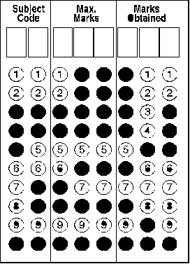
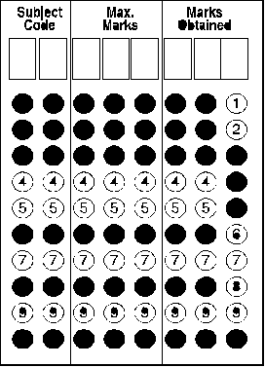
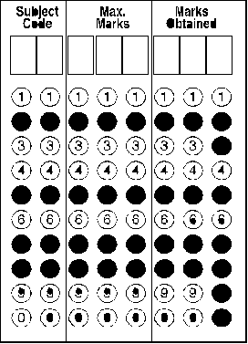
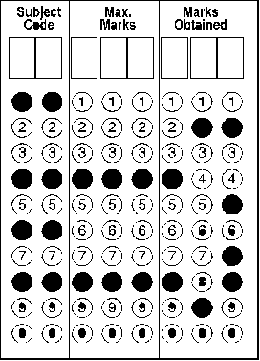
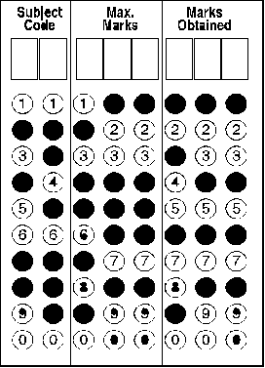
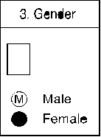
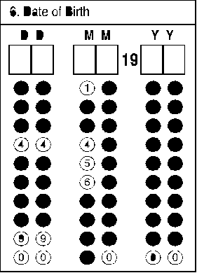
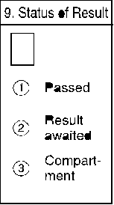
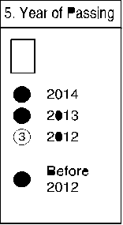
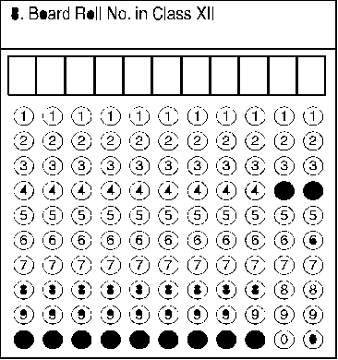
39

40

